**12/10/2021 CD LAB 6 2019103573**

**1. Convert the given switch case statement to else if statement.**

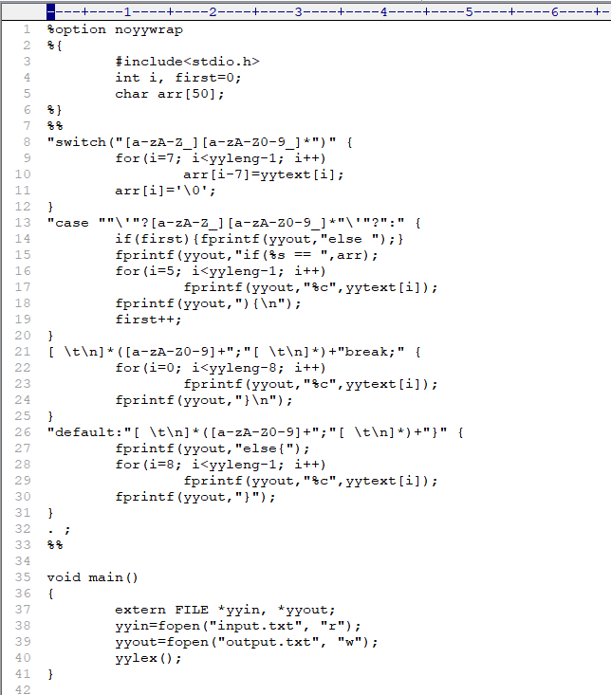**CODE :-**

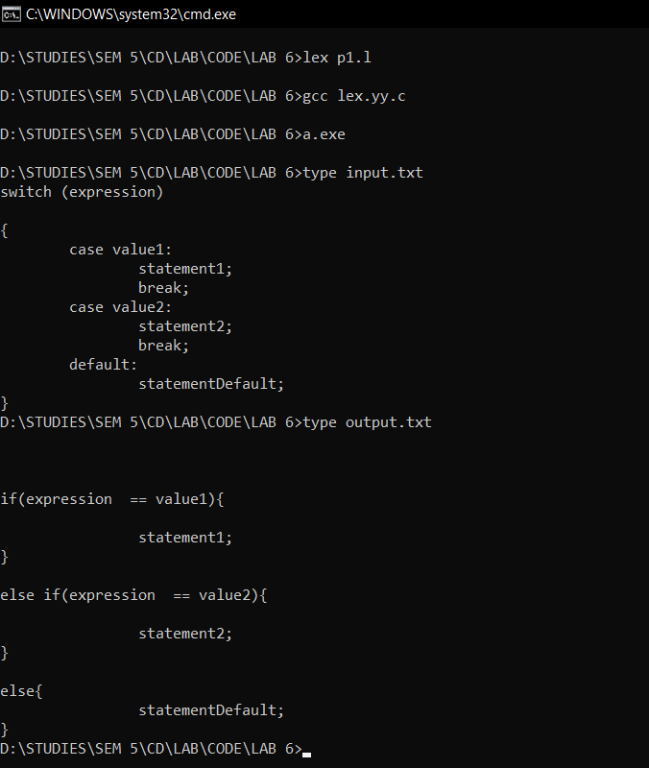**OUTPUT :-**

**2. Write a program to convert the given function to macro.**

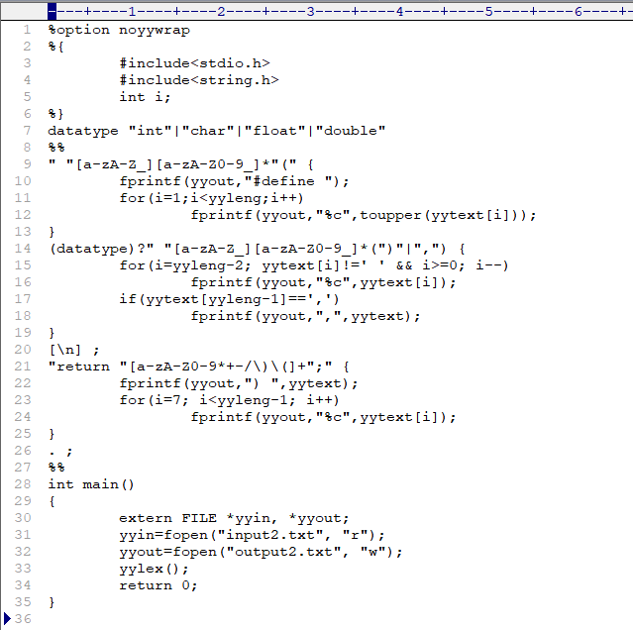**CODE :-**

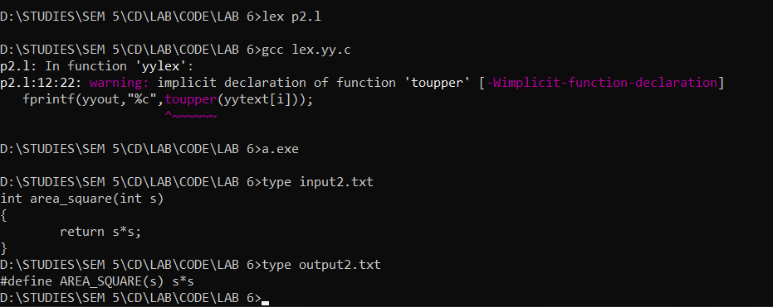**OUTPUT :-**

**3. To write a program to convert the given infix expression to postfix expression(with parenthesis).**

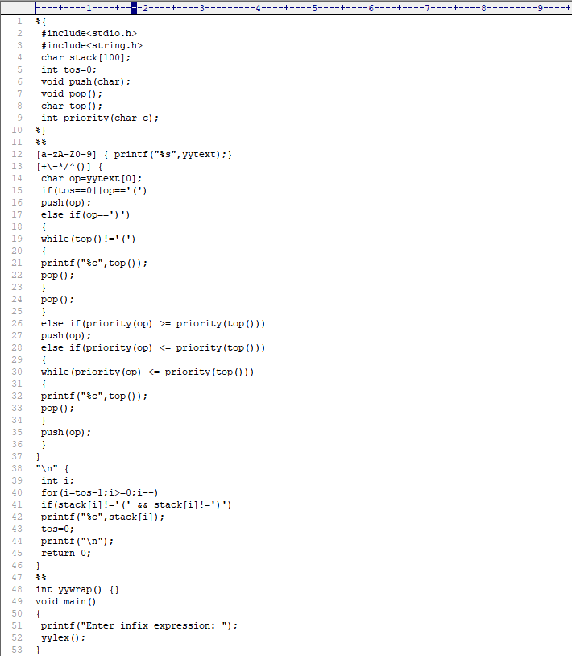**CODE :-**

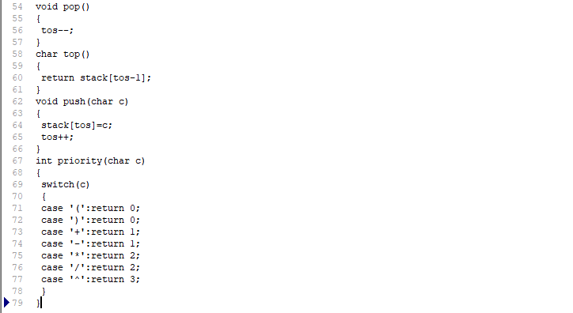

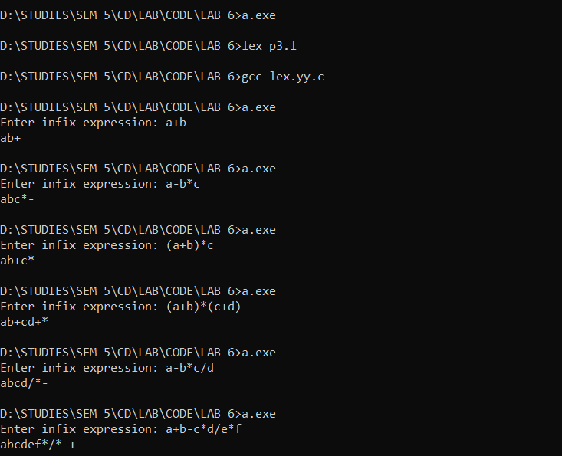**OUTPUT :-**